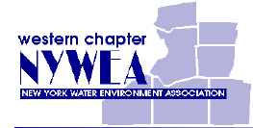

Western New York Water Environment Association
Young Professionals
Fall Social Event

vs
The Rochester Americans The Hamilton Bulldogs

Tuesday, October 23rd
7:35 PM
First Niagara Center, Buffalo NY

Free to members and young professionals.
$10 for non-members

The WNYWEA Young Professionals would like to thank Arcadis and GHD for their help in making this event possible.

